# **Simple VLAN Configuration for Office Network**

## **Introduction:**

This project aims to demonstrate a basic Virtual Local Area Network (VLAN) configuration using Cisco Packet Tracer. The objective is to logically segment an office network into two distinct departments, Human Resources (HR) and Administration (Admin), even though they share the same physical switch. This segmentation enhances network security, improves performance by reducing broadcast domains, and simplifies network management.

## **2. Network Topology:**

The network topology consists of the following components (Figure 1):

* 1 x Cisco 2960 Series Switch: Acts as the central networking device.
* 4 x End Devices (PCs):

1. PC0
2. PC1
3. PC2
4. PC3

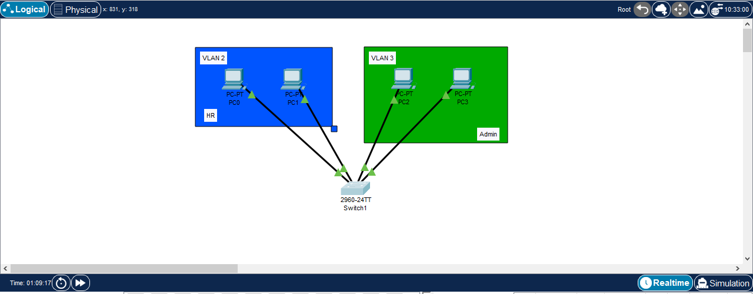

### Figure 1: Network Topology Design

**3. IP Addressing Scheme**:

All PCs are assigned static IP addresses within the same subnet (192.168.1.0/24) to initially allow for basic connectivity before VLAN implementation.

* PC0: 192.168.1.1
* PC1: 192.168.1.2
* PC2: 192.168.1.3
* PC3: 192.168.1.4

## **4. VLAN Configuration Details:**

To achieve departmental separation, two VLANs were created and configured on the switch:

* VLAN 2 (HR Department):
* Purpose: To group devices belonging to the Human Resources department.
* Assigned Devices: PC0 and PC1
* VLAN 3 (Admin Department):
* Purpose: To group devices belonging to the Administration department.
* Assigned Devices: PC2 and PC3

## **5. Configuration Steps (Command Line Interface - CLI on Switch):**

The following general steps were performed on the Cisco switch's CLI to configure the VLANs and assign ports (Figure 2):

* Enter Global Configuration Mode:
* enable
* configure terminal
* Create VLAN 2 (HR Department):
* vlan 2
* name HR
* exit
* Create VLAN 3 (Admin Department):
* vlan 3
* name Admin
* exit
* Assign Ports to VLAN 2 (HR Department):

Identify the switch ports connected to PC0 and PC1 (e.g., FastEthernet0/1 and FastEthernet0/2).

* interface FastEthernet0/1
* switchport access vlan 2
* exit
* interface FastEthernet0/2
* switchport mode access vlan 2
* exit
* Assign Ports to VLAN 3 (Admin Department):

Identify the switch ports connected to PC2 and PC3 (e.g., FastEthernet0/3 and FastEthernet0/4).

* interface FastEthernet0/3
* switchport access vlan 3
* exit
* interface FastEthernet0/4
* switchport mode access vlan 3
* exit

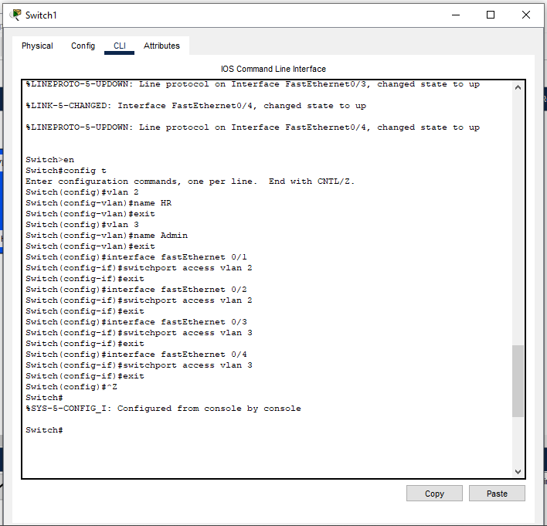

### Figure 2: VLAN Configuration

## **6. Verification:**

After configuration, connectivity was verified:

* Intra-VLAN Communication: PCs within the same VLAN (e.g., PC0 to PC1, or PC2 to PC3) were able to ping each other successfully.
* Inter-VLAN Isolation: PCs in different VLANs (e.g., PC0 to PC2) were unable to ping each other, demonstrating successful segmentation.

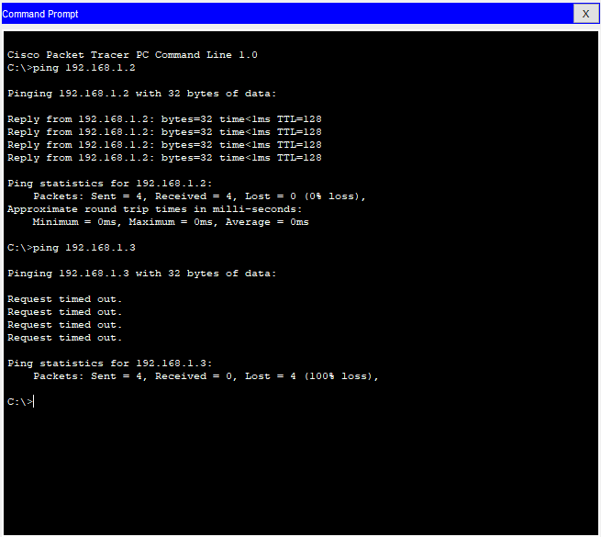

### Figure 3: Ping test of connections

## **7. Conclusion:**

This project successfully demonstrated the implementation of basic VLANs in Cisco Packet Tracer to logically separate network devices into distinct departments. By assigning PC0 and PC1 to VLAN 2 (HR) and PC2 and PC3 to VLAN 3 (Admin), effective departmental isolation was achieved. This setup provides a foundational understanding of VLAN technology, which is crucial for building scalable, secure, and manageable office networks. Further enhancements could include inter-VLAN routing for controlled communication between departments, if required.